Endpoints for comments table:

URI: /api/comments

Method: GET

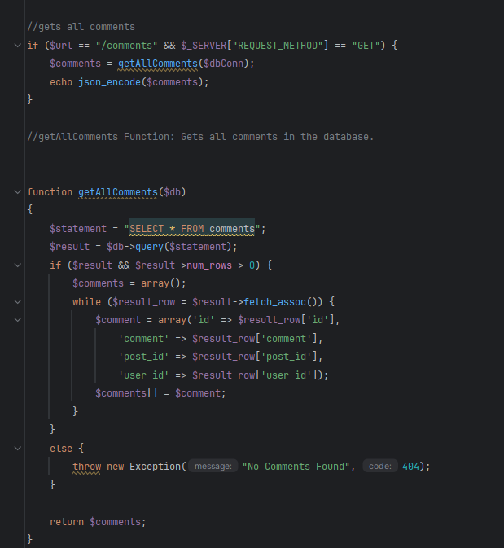

The code above tests the endpoint and lists all comments from the database using the function getAllComments().

In a real application, the return should be all of the comments that are stored in the database.

URI: /api/comments/{id}

Method: GET

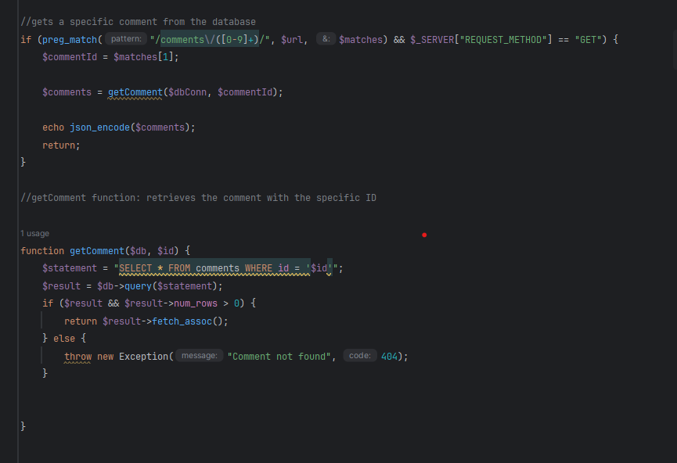

The code above uses the getComment() function to grab a comment with a specific ID from the database and display it. If the comment ID does not exist, it will run an Error.

URI: /api/posts/{postId}/comments

Method: GET

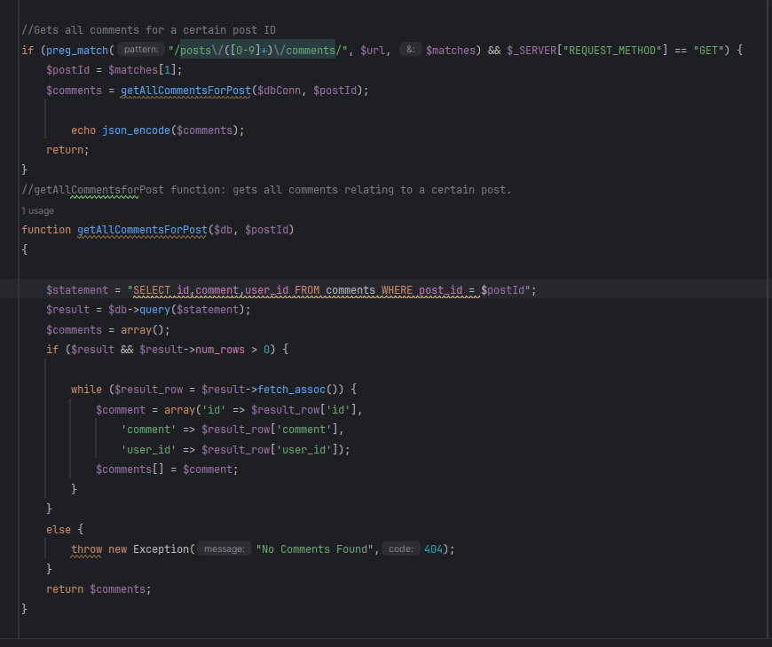

This code uses the getAllCommentsForPost() method and grabs all of the comments that share a post ID with the post displayed in the endpoint. If the post does not exist or there are no comments for said post, an error will appear.

URI: /api/posts/{postId}/comments

Method: POST

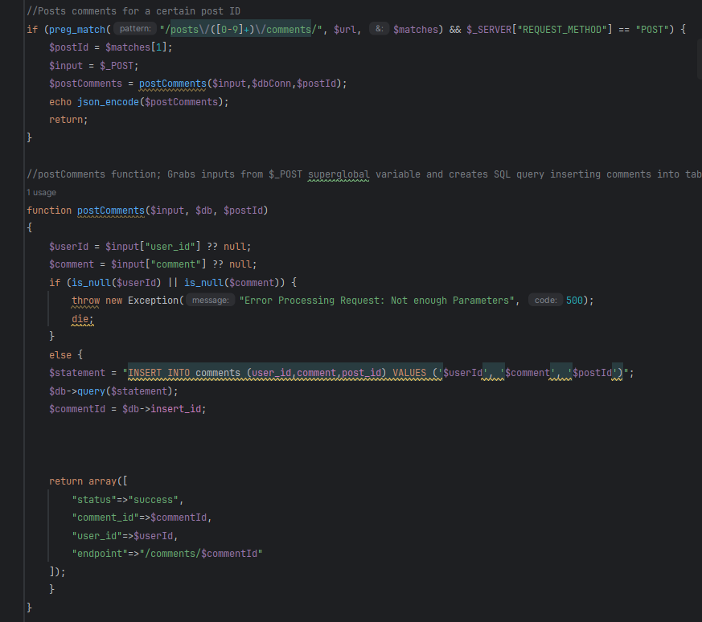

This endpoint uses the postComments() function to post a comment into the database. **NOTE:** If the post ID is invalid or the data that is being posted is not fully filled out, an error will occur.